

Title of the Document : **IBM BPM Migration**

Author : **Harish Kumar Dash**

Reviewed By :

Signed Off By :

Date Completed : **1st August 2019**

Table of Contents Page No

1. Introduction: 3

1.1 Migration 3

1.2 Upgrading IBM BPM V8.5.x to IBM Business Automation Workflow Version 19.0.0.1 3

2.Requirements: 3

IBM Business Automation Workflow Version 19.0.0.1 3

3. Backup the Databases & Profiles 3

5. Upgrading the Database 10

6. Upgrading BPM Configuration : 15

7.Reference: 19

# 1. Introduction**:**

## **1.1 Migration**

Migrating refers to the process of moving applications and configuration information from an earlier version of a product to a later version of the product, or from one product to a different product. Upgrading refers to the process of installing a new release of the product on top of the previous release and updating the existing installation, configuration, and database in place.

## 1.2 Upgrading IBM BPM V8.5.x to IBM Business Automation Workflow Version 19.0.0.1

During the upgrading process, you install a new release of the IBM Business Automation Workflow Version 19.0.0.1 product update BPM 8.5.6 the existing installation, configuration, and database in place. You must back up your profiles and databases before upgrading. A profile defines a unique run time environment, with separate command files, configuration files, and log files. Profiles define the following types of environments in IBM Business Process Manager: stand-alone server, deployment manager, and managed node.

# **2.Requirements:**

**To Migrate BPM Environment, the following are needed:**

# **IBM Business Automation Workflow Version 19.0.0.1**

* **WebSphere Application Server V 8.5.5.15**
* **Oracle12c(release2)**
* **Process Server Environment to migrate.**
* **SDK 8**

# 3. Backup the Databases & Profiles

Before going to install we need to backup the BPM profiles and Databases.

**For Oracle DB BPM 8.5 x Product User/Schema ( cmnuser, psuser, pdwuser & celluser) Backup :**

EX- **expdp schema_name/password@sid_name full=Y directory=TEST_DIR dumpfile=exp_schm.dmp logfile=schm.log**

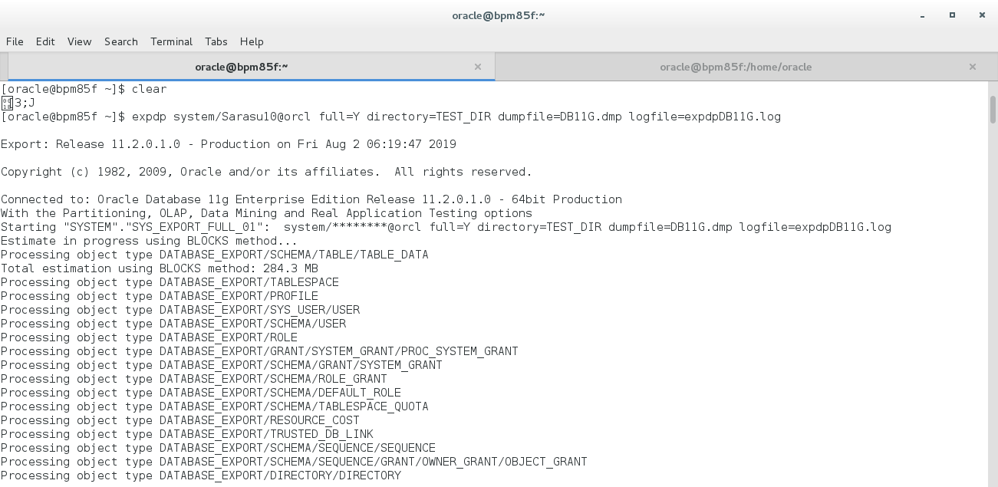

**For BPM Profiles Backup:**

**EX- <profile_path>/bin/ ./backupConfig.sh backup-file [-location <location>]/<profile_name.zip> -username <profile_username> -password <profile_password> -profileName <profile_name>**

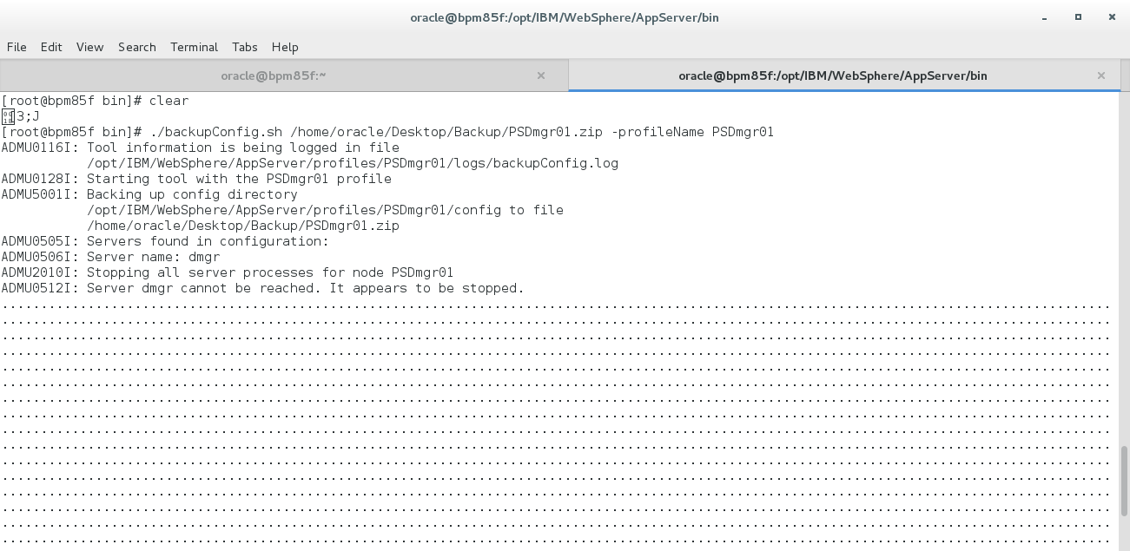

**Note :** Repeat the same process to backup both the Node profiles.

**After BPM Process Server Deployment Manager profile backup, we will use same command for Node profile Backup**

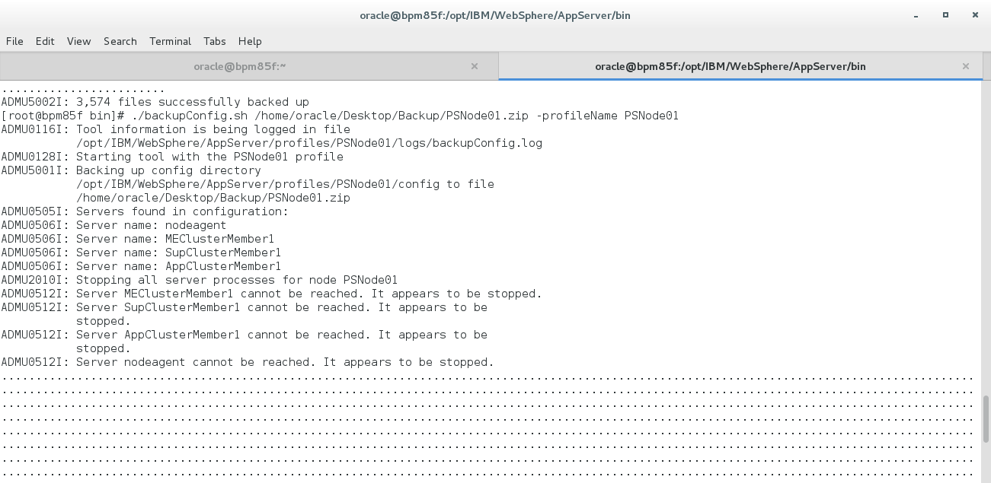**4****. Upgrading an installation interactively(GUI)**

If you have an existing IBM BPM deployment environment,you need to follow the below steps

1. Start IBM Installation Manager <IM_installation_path>/IBMIM
2. **Note:** Installation manager must be at a minimum level of Version 1.8 before you start the IBM Business Automation Workflow 19.0.0.1 installation updates.
3. Add the repositories to the Installation Manager preferences. Click **File** > **Preferences**. Under **Repositories** add the repositories of WAS ND ,BAW 18.0.0.1 and JDK 1.8

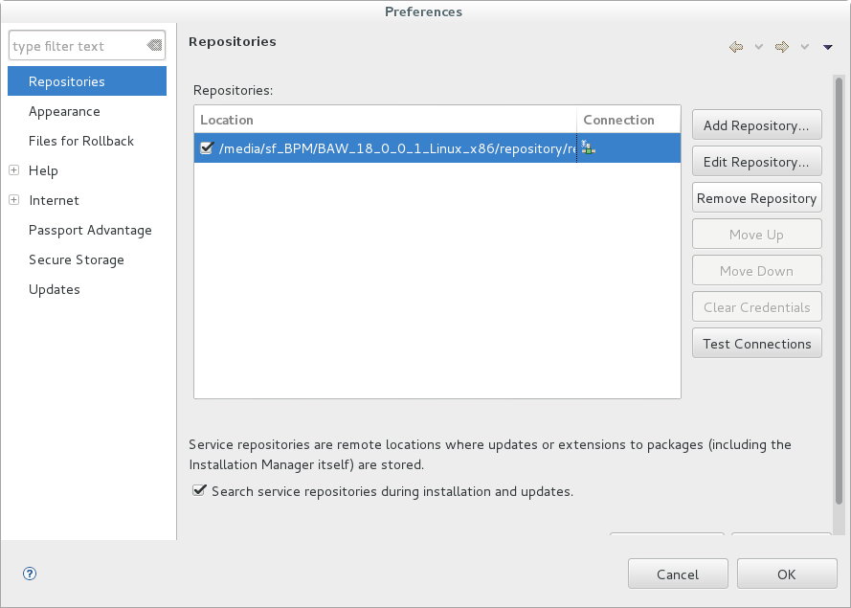

1. Click **Update**. Select the package group where you installed IBM BPM V8.5.6 and click **Next**.

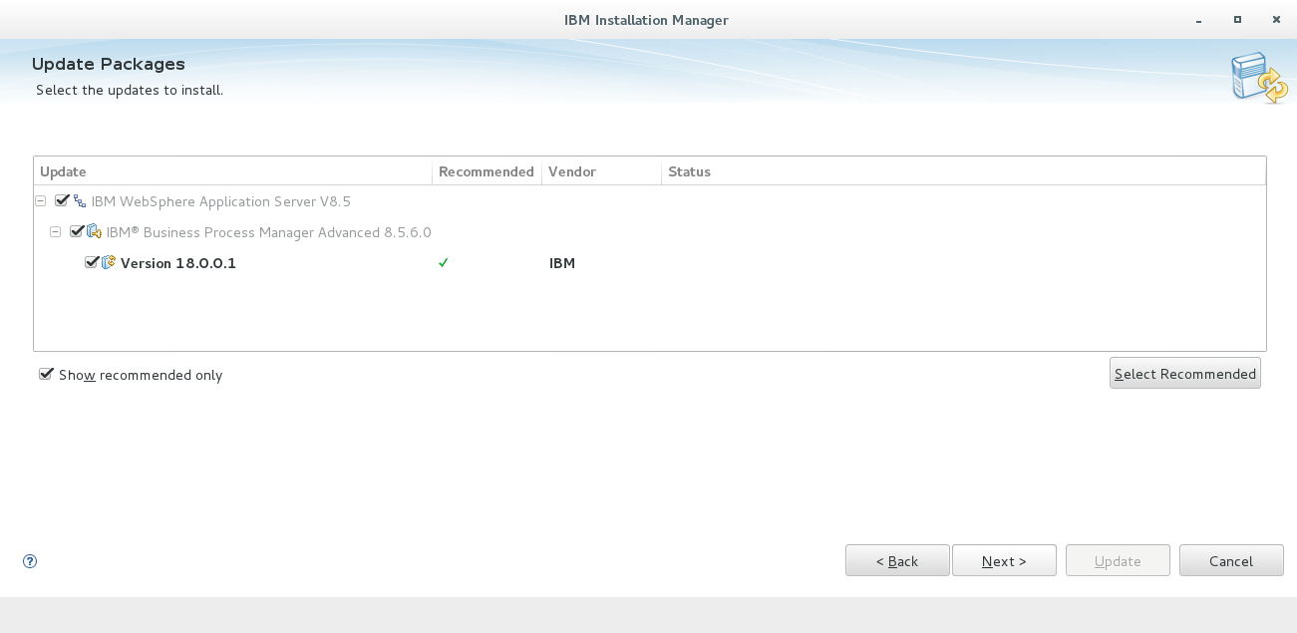

1. Click on **accept the license agreement** and then Click **Next**

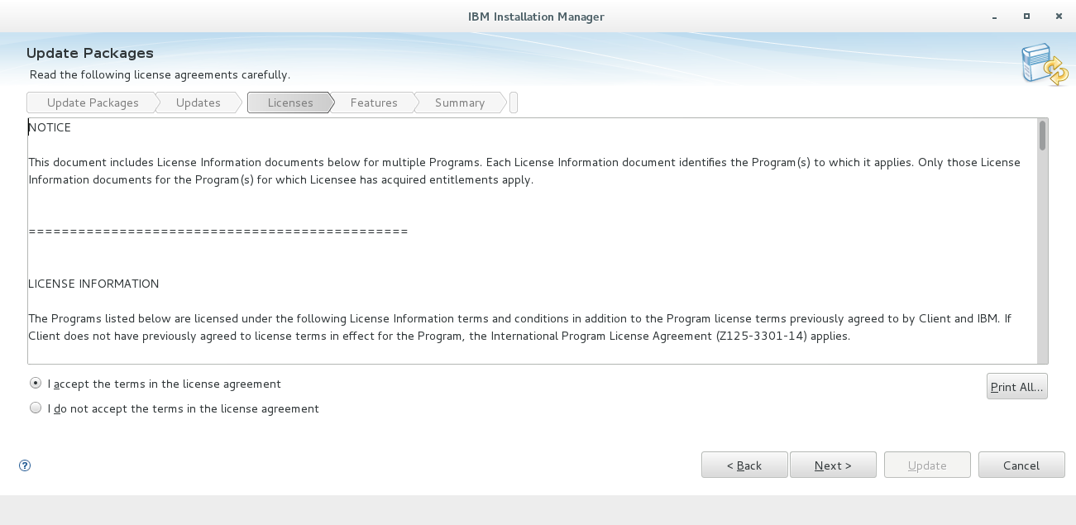

1. If required check the updates recommend level fix packs

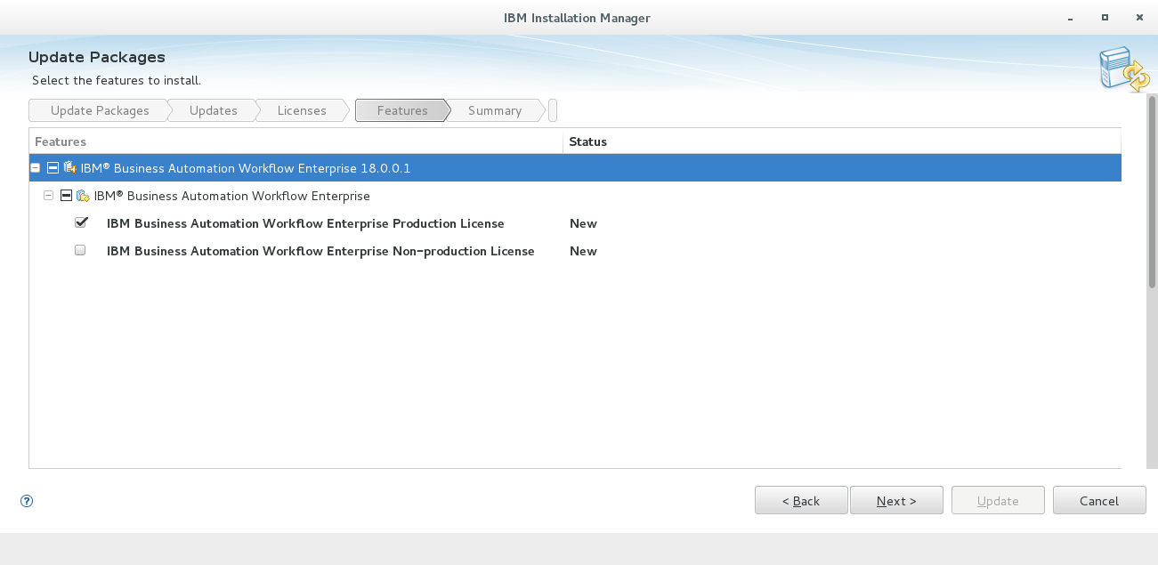

1. After that click **Next** and then click **Update**

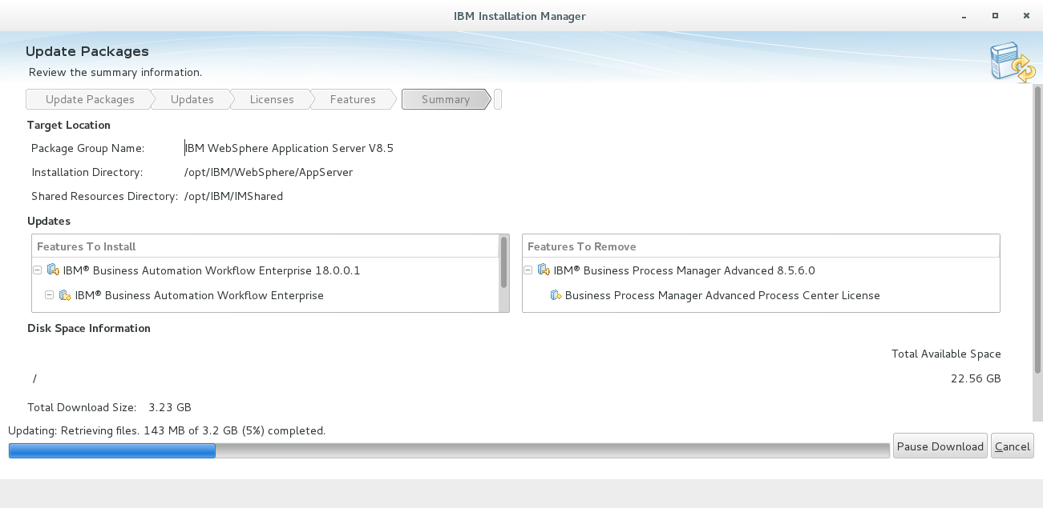

1. If node is in remote we have to update the node environment also.
2. After Updating from 8.5.6 we will get the latest version 8.6.1.18001 after that we need to add the cumulative fix pack repository of BAW V19.0.0.1
3. Add the repositories to the Installation Manager preferences. Click **File** > **Preferences**. Under **Repositories** add the repository.config file of cumulative fix of BAW V19.0.0.1

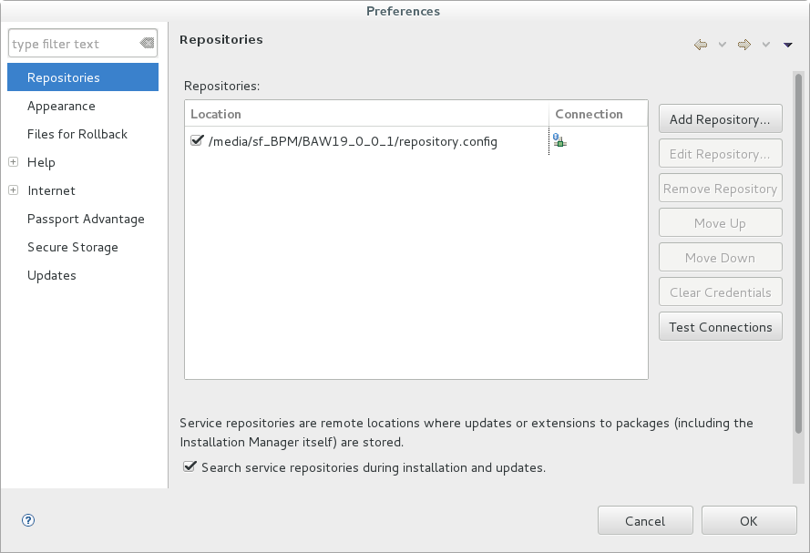

1. Click **Update**. Select the package group where you installed IBM BAW V18.0.01 and click **Next**.

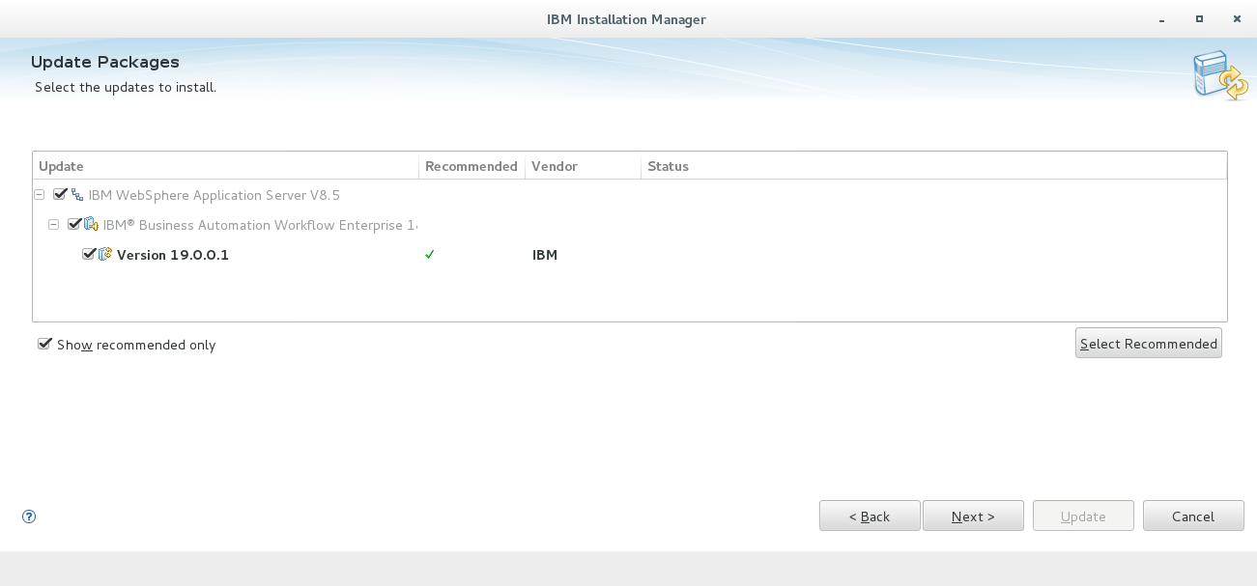

1. Click on **accept the license agreement** and then Click **Next**

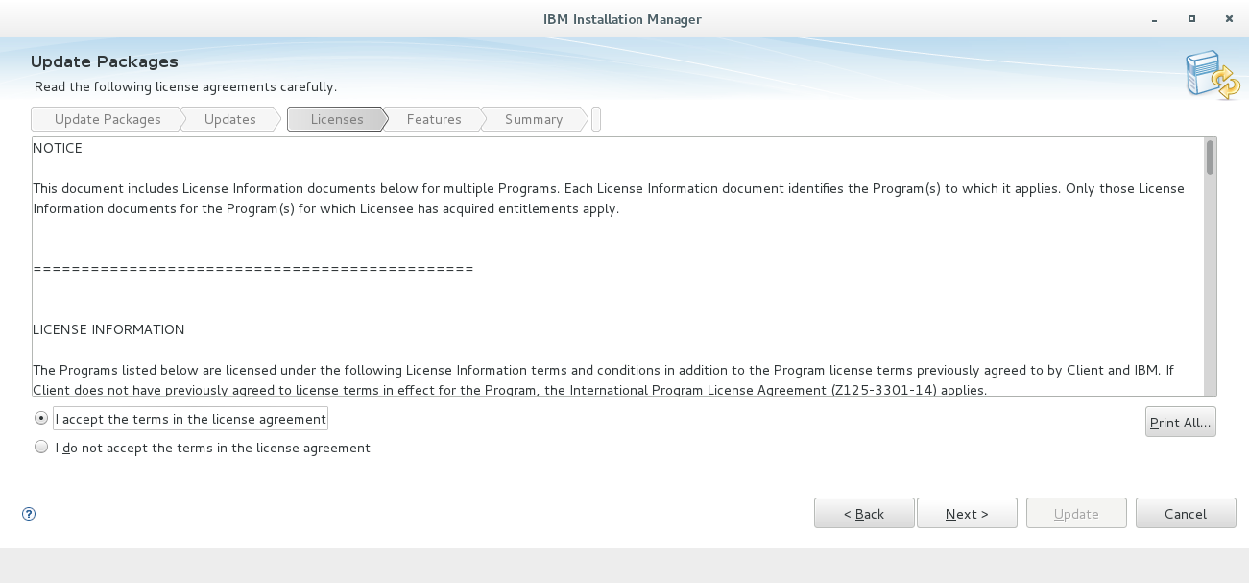

1. If required check the updates recommend level fix packs

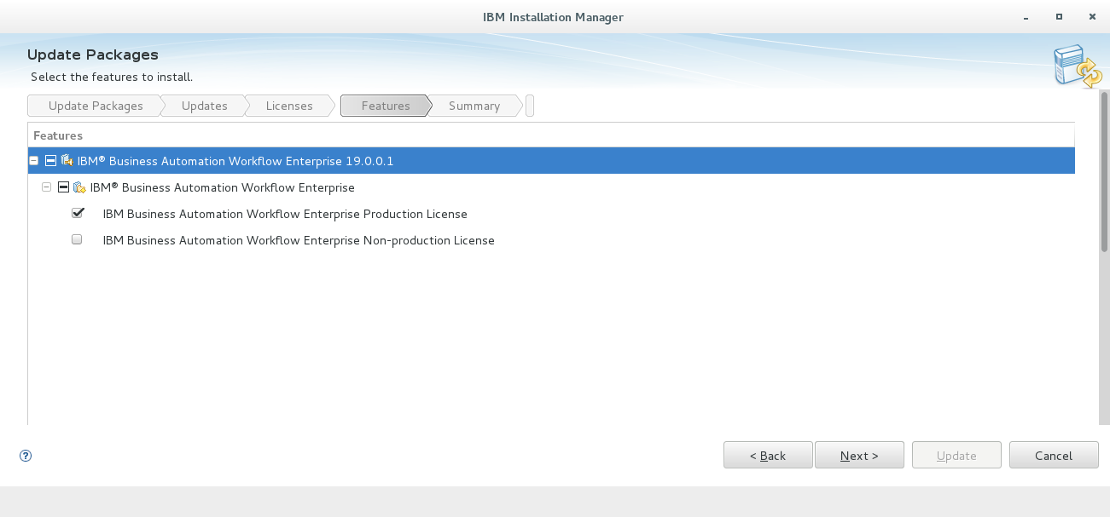

1. After that click **Next** and then click **Update**

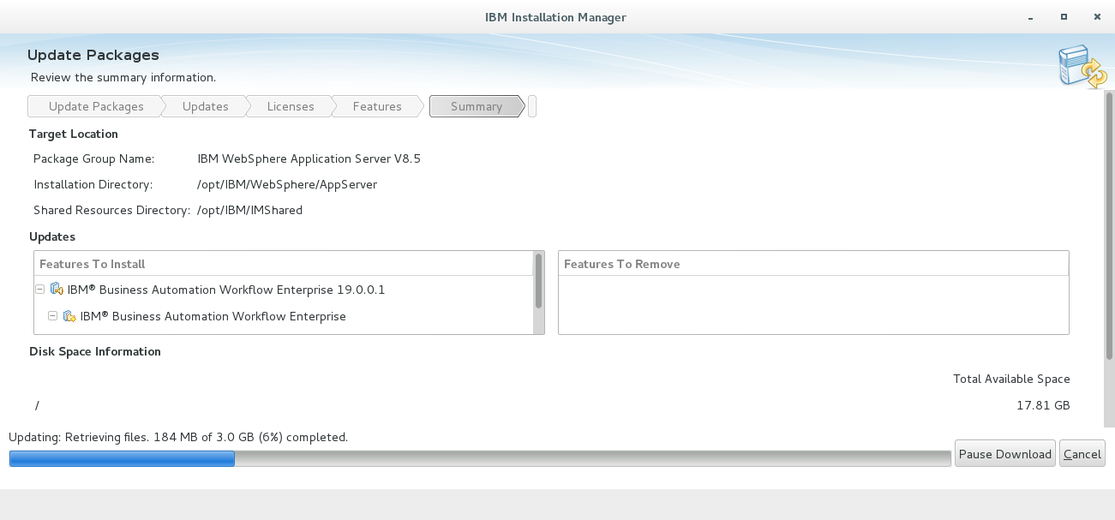

1. Once complete the update check the version of BAW, WAS ND, JDK
2. we can check the versions by running this command <WAS_Home>/bin/**versionInfo.sh**

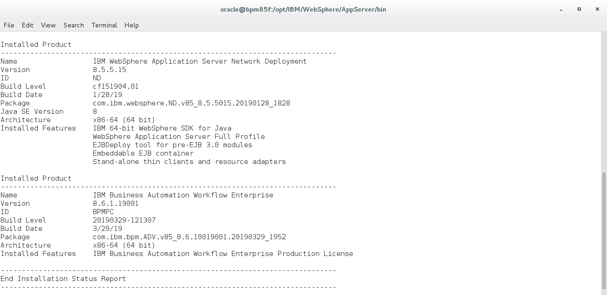

1. If you installed Java 8,you must run the following two commands: **install_root/bin/managesdk.sh -setCommandDefault -sdkname 1.8_64**  
   **install_root/bin**/**managesdk.sh -setNewProfileDefault -sdkname 1.8_64**

# 5. Upgrading the Database

Before Upgrading the Database First We need to follow some below additional steps:

**1.** Copy the **ojdbc7.jar** and **ojdbc8.jar** files into **${WAS_INSTALL_ROOT}/jdbcdrivers/Oracle** directory.

**2.** If Java 7 is installed in your source environment, run the following command to switch your default profile to use Java 8 before you run DBUpgrade

Ex- **install_root/bin/managesdk.bat/sh -enableProfile -profileName <profile_name> -sdkName <sdk_name> -enableServers**

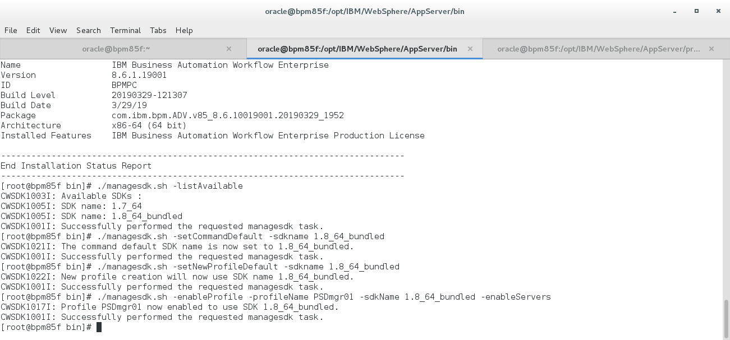

**3.** Run the following command to collect the data source information for IBM Content Navigator (ICN). This command also collects the data source information for the design object store (DOS) and target object store (TOS) components for the embedded Content Platform Engine.

Ex-**<WebSphere_install_root>/bin/BPMConfig.sh -update -profile <deployment_manager_profile_Name> -de <deployment_environment_name> -caseConfigure**

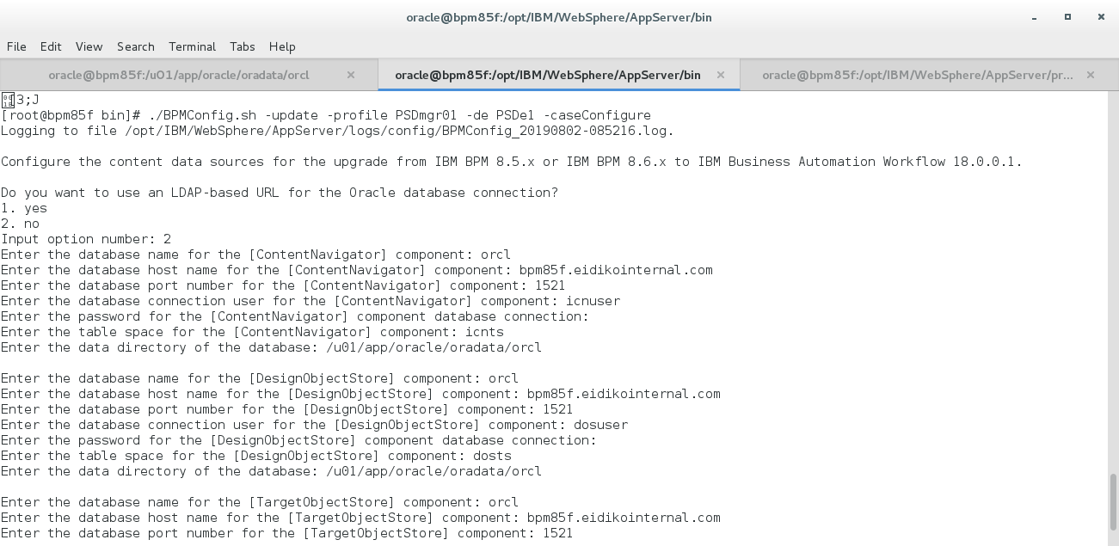

**4.** Create two users and table spaces for the design object store (DOS) and target object store (TOS). Find the table space creation file in **dmgr_profile_root/dbscripts/cell_name.deployment_environment_name/Oracle/database_name/db_user** where db_user is the DOS and TOS database users.  
Run the following sql file on the Oracle database computer   
 Ex- **@ createUserTablespace_ECM.sql**

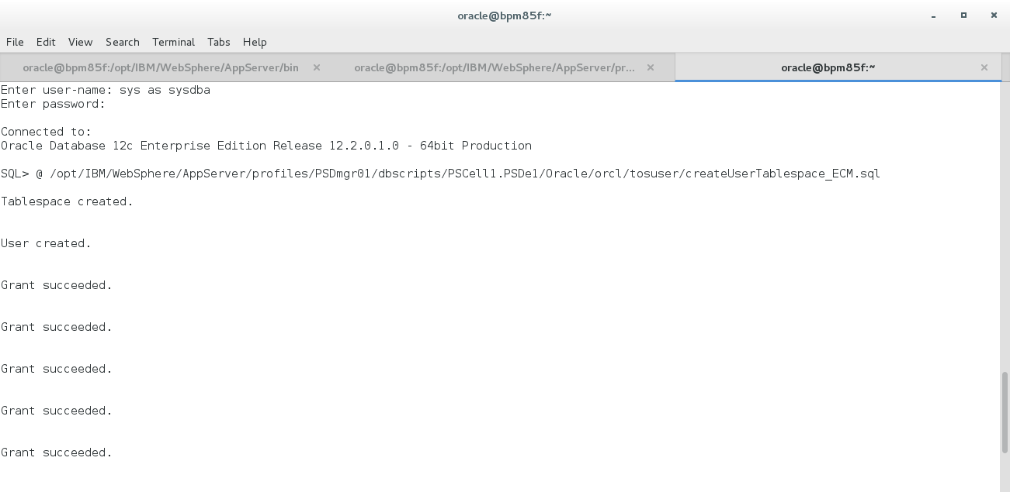

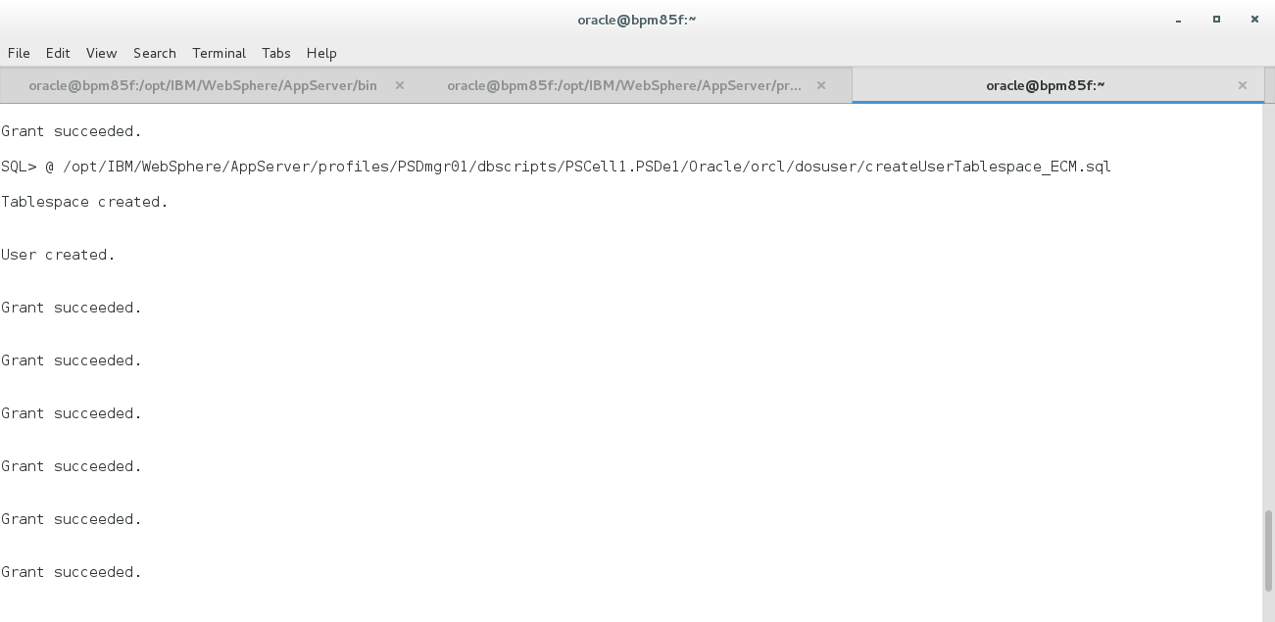

**5.** Prepare the Oracle databases for IBM Content Navigator (ICN) Find the user and table space creation files in **dmgr_profile_root/dbscripts/cell_name.deployment_environment_name/Oracle/database_name/db_user**  
Run the following files on the database computer

Ex- **@ createUser.sql  
 @ createTablespace_ICN.sql**

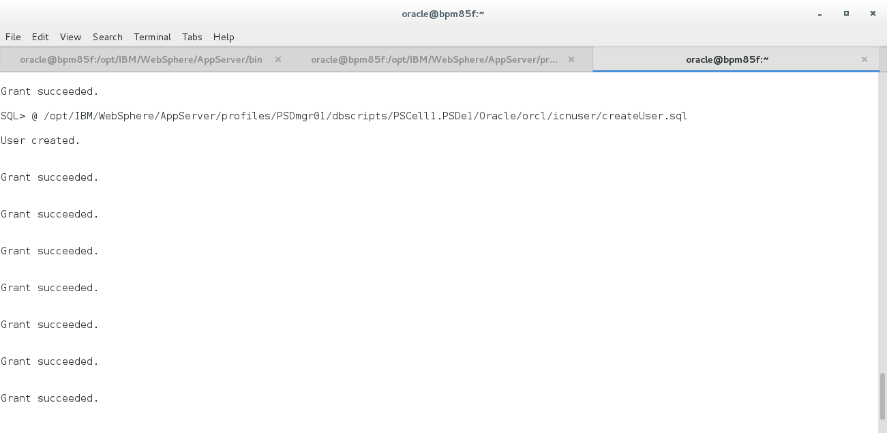

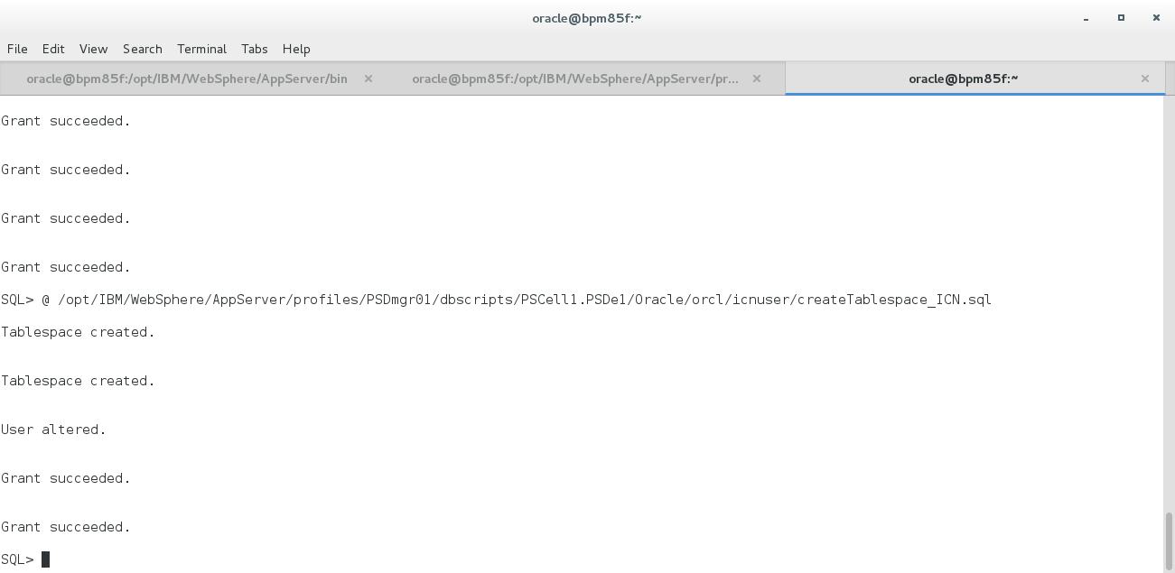

**6.** Run the DBUpgrade -validate command to make sure that your configured database user i.e (cmnuser,psuser,pdwuser,celluser,tosuser,dosuser and icnuser) has sufficient permissions to upgrade the database

Ex- **<install_root>DBUpgrade.sh -validate -profileName deployment_manager_profile [-de deployment_environment_name] -bpmSchemaAdminUser <bpmSchema-AdminUser> -bpmSchemaAdminPassword <bpmSchema_AdminPassword>**

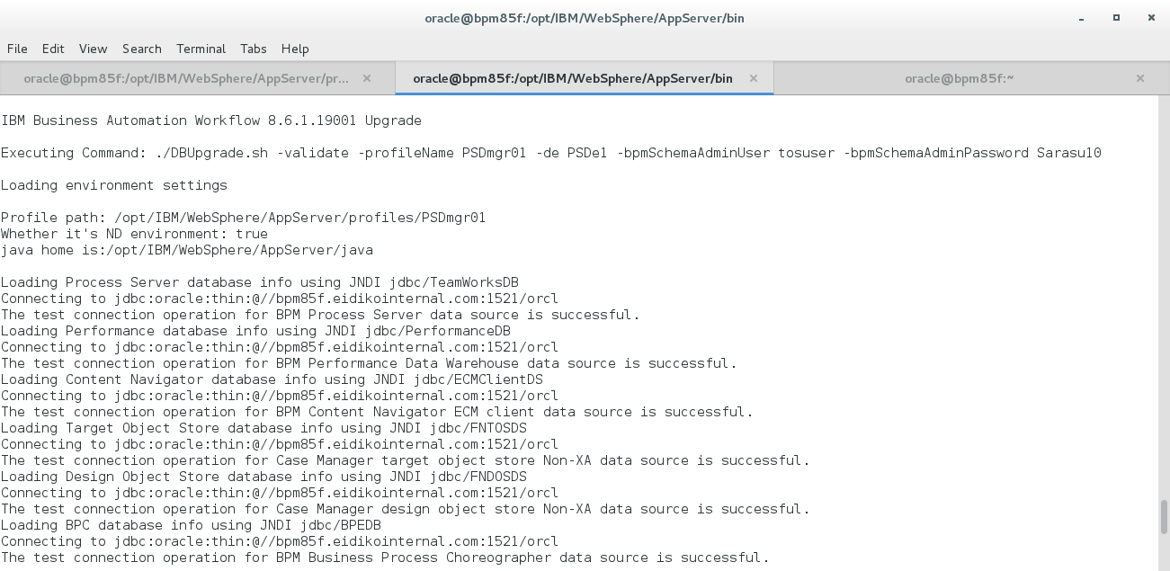

**by using above command we can validate**

**7.** Then Run the following commands to upgrade your database and make sure that DBUpgrade command has finished successfully before you move to the next step

Ex- **<install_root>/bin/DBUpgrade.sh -profileName deployment_manager_profile -de <deployment_environment_name>**

# 

# 6. Upgrading BPM Configuration :

Run the command **<install_root>/bin/BPMConfig.sh -upgrade -profile <Dmgr_profile>**

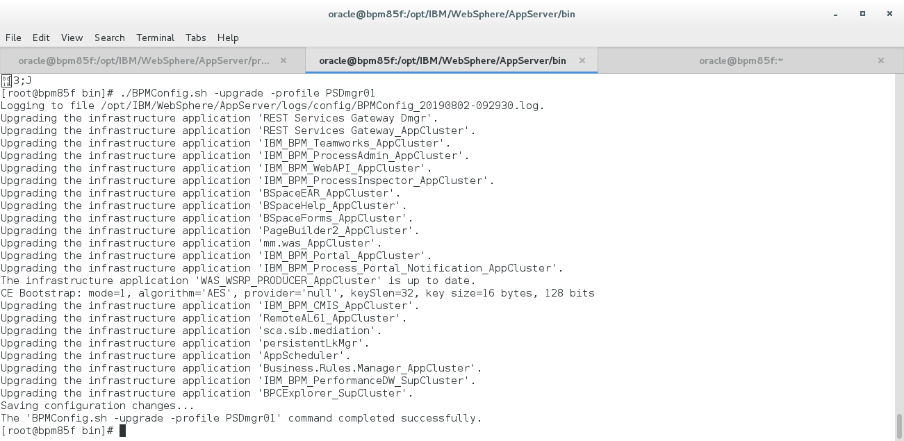

1. Once completed with the BPM configuration upgrade,we have to run the following bootstrap command before starting the Deployment Manager

Ex-**<BPM_Dmgr_Profile>/bin ./bootstrapProcessServerData.sh -clusterName AppCluster**

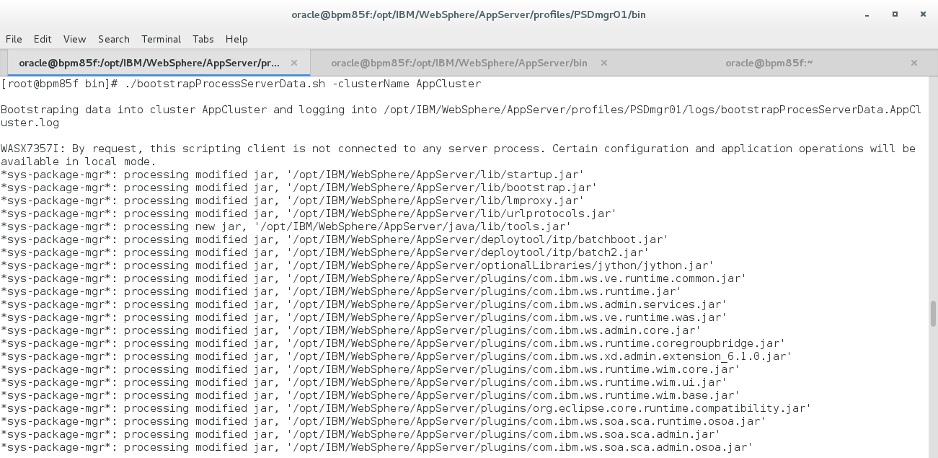

1. After Successfully run the above bootstrap command then Start Deployment Manager **<profile_path>/bin**/**startManager.sh**
2. Go to <Node_profile>/bin and **syncNode.sh** command need to run to effect the configuratons.

**Note :** Before running syncNode command node agent should be stopped.

Ex- **syncNode.sh <dmgr_Host_Name> 8879 -profileName <node_profile_name> -user <admin_User_name> -password <admin_password_name>**

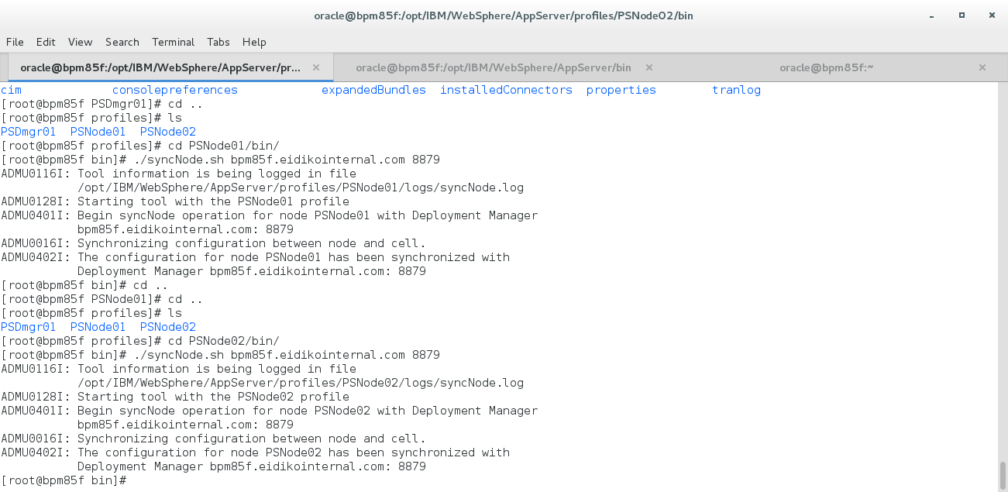

1. Enable all servers with sdk1.8 run the below command

Ex- **<Install_root>bin/managesdk.sh -enableProfile -profileName <node_profile> -sdkname 1.8_64 -enableServers**

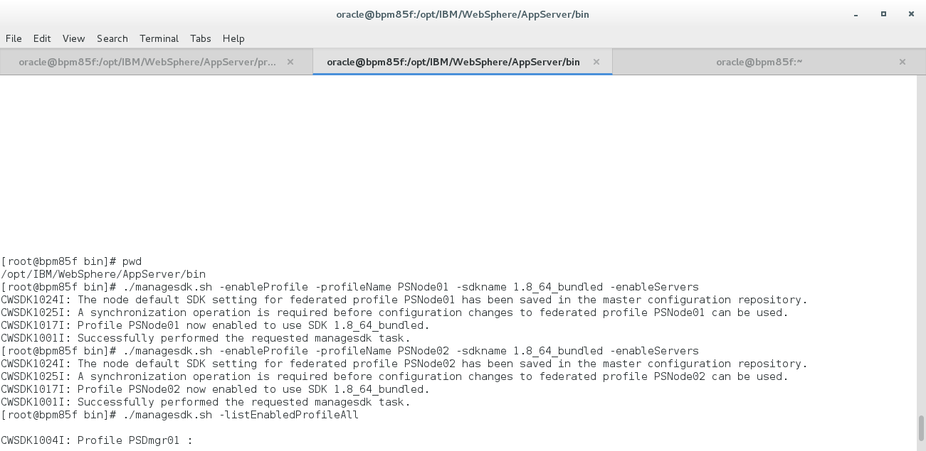

1. Validate the changes by running the ./**managesdk.sh -listEnabledProfileAll**

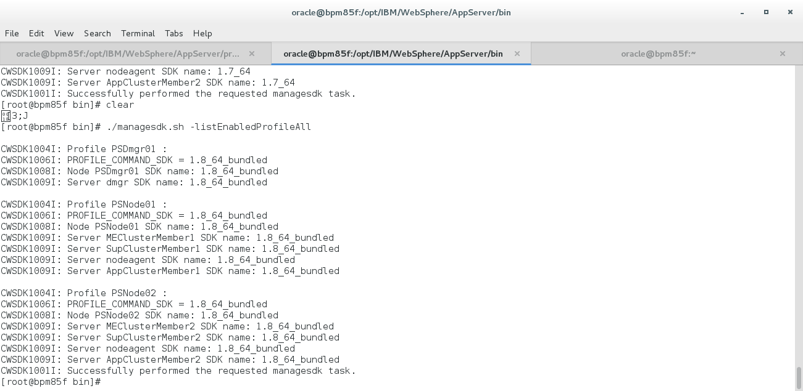

1. Again we need to run **syncNode.sh** command to effect the configurations.
2. After that type the below command to upgrade both BPM Node profile

Ex-**./BPMConfig.sh -upgrade -profile <node_profile_name>**

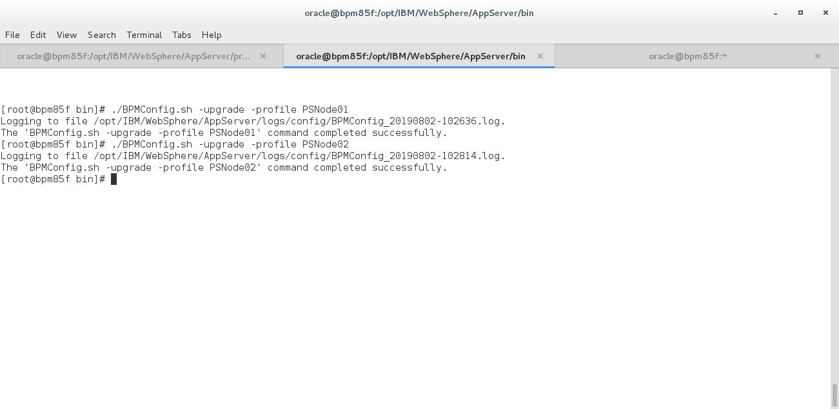

1. Start the both Managed Node <node_profile>/bin/**startNode.sh**

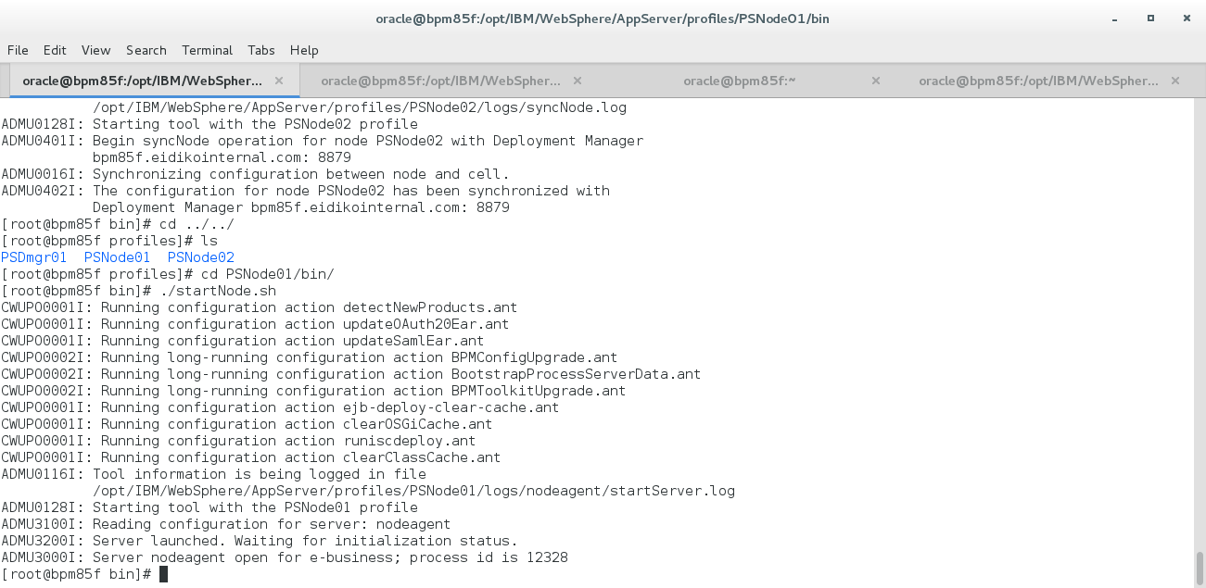

1. Start the Deployment Environment >node_profile>/bin/**startServer.sh <****server_name>**

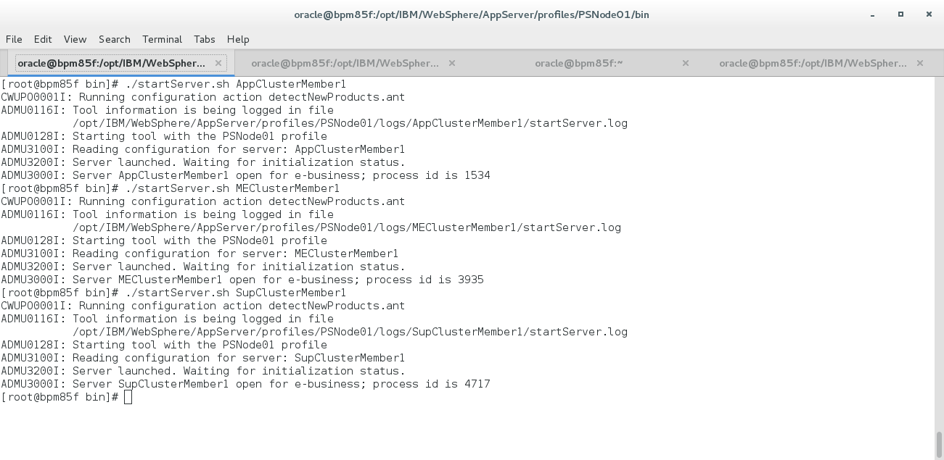

# 7.Reference:

https://www-01.ibm.com/support/docview.wss?uid=ibm10795177#errors